Supplementary material

Index |  | P1
Supplementary Table 1 | Characteristics of excluded studies | P1
Supplementary Fig. 1 | Funnel plot of mortality data | P1
Supplementary Fig. 2 | Forest plot of the reported mortality data’s subgroup analysis | P2
Supplementary Fig. 3 | Forest plot of length of hospital stay | P3
Supplementary Fig. 4 | Forest plot of Intensive Care Unit admission | P3
Supplementary Fig. 5 | Forest plot of C-reactive protein levels (mg/L) after treatment | P3
Supplementary Fig. 6 | Randomized studies risk of bias | P4
Supplementary References |  | P4

Supplementary Table 1. Characteristics of excluded studies.
First author, Publication year | Study design | Covid status | Longest follow-up available | Exclusion criteria
Alizadeh, 2021 [2] | RCT | mild to moderate outpatients | 14 days | No mortality data reported
García, 2022 [5] | RCT | healthcare workers at high risk of SARS-CoV-2 exposure | 12 weeks | Melatonin used in healthcare workers as prophylaxis
Rodríguez-Rubio, 2020 [6] | RCT | critical | 28 days | Methodological manuscript
Ziaei, 2021 [4] | RCT | moderate | 7 days | Methodological manuscript
Zhou, 2020 [1] | PSM | hospitalised | - | No mortality data reported
Abbreviations: RCT—Randomized controlled trial; PSM—propensity matched study.

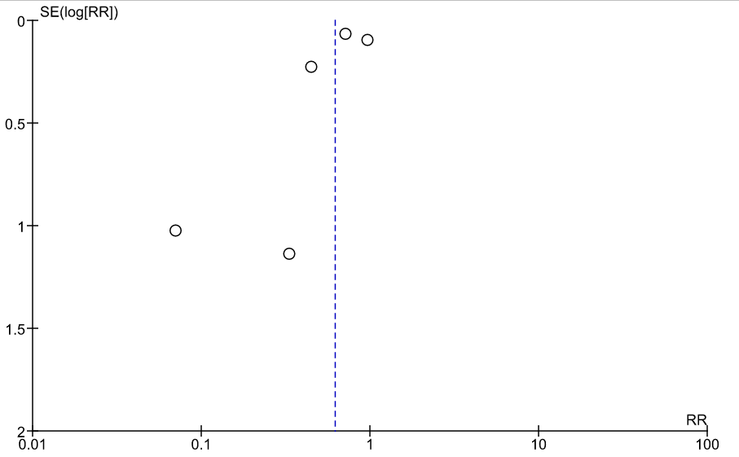
Supplementary Fig. 1. Funnel plot of all (n = 8) the articles reporting mortality data. In three cases no death occurred.

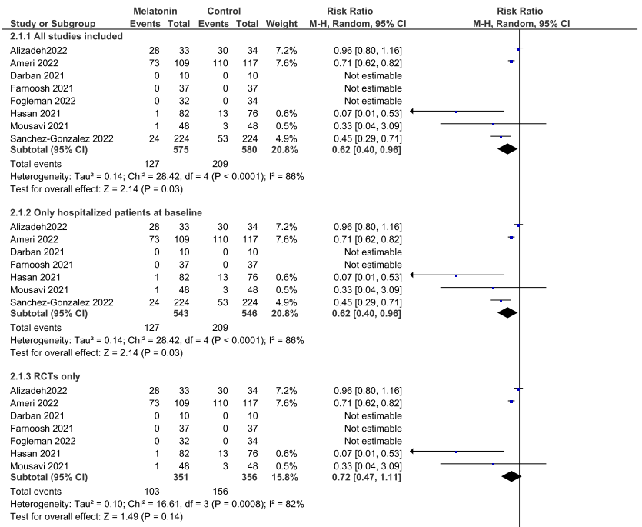
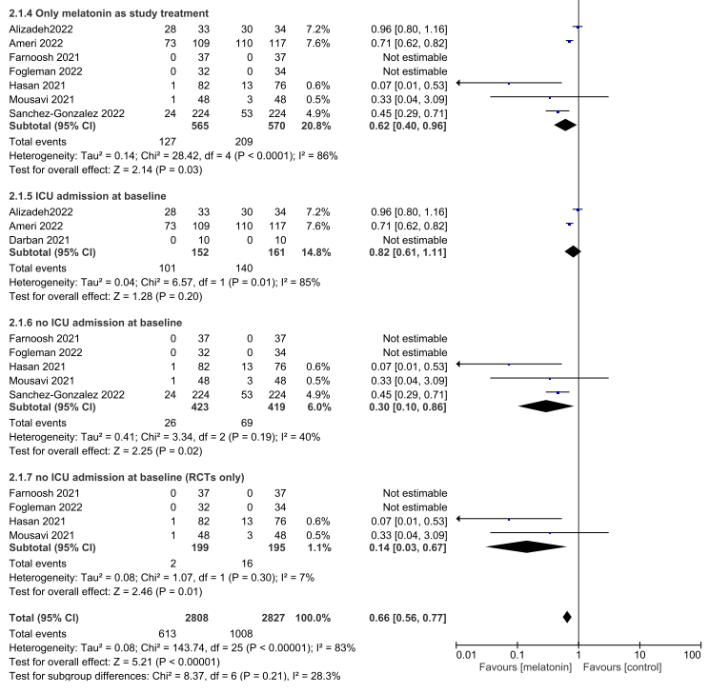
Supplementary Fig. 2. Forest plot of the reported mortality data’s subgroup analysis. 2.1.1 All studies included in the meta-analysis. 2.1.2. Only hospitalized patients at baseline. 2.1.3. All included RCTs (randomized controlled trials) in the meta-analysis. 2.1.4. All studies that used only melatonin in the experimental group as an adjuvant. 2.1.5. Articles that involved only patients who were admitted to the Intensive Care Unit (ICU) at the baseline. 2.1.6. Studies where participants were not admitted to the ICU at the baseline. 2.1.7. Only RCTs where participants were not admitted to the ICU at the baseline.

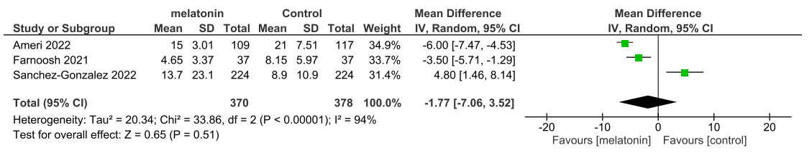
Supplementary Fig. 3. Three articles reported data about length of hospital stay. There was no significant difference.

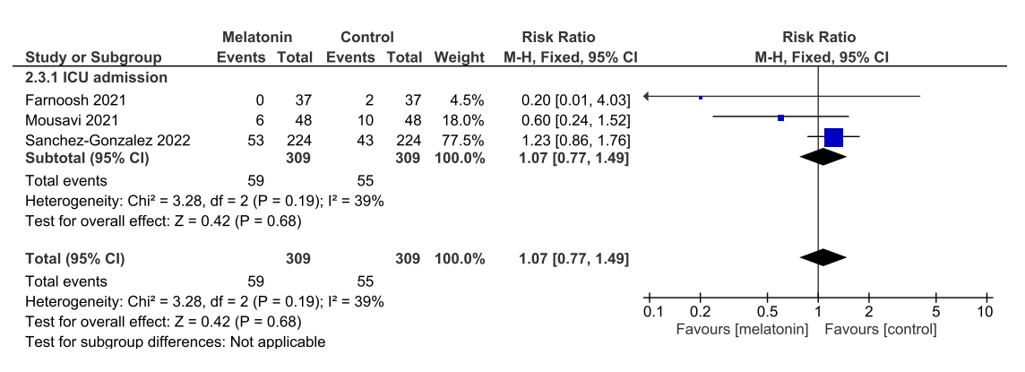
Supplementary Fig. 4. Three articles reported data about Intensive Care Unit admission. There was no significant difference.

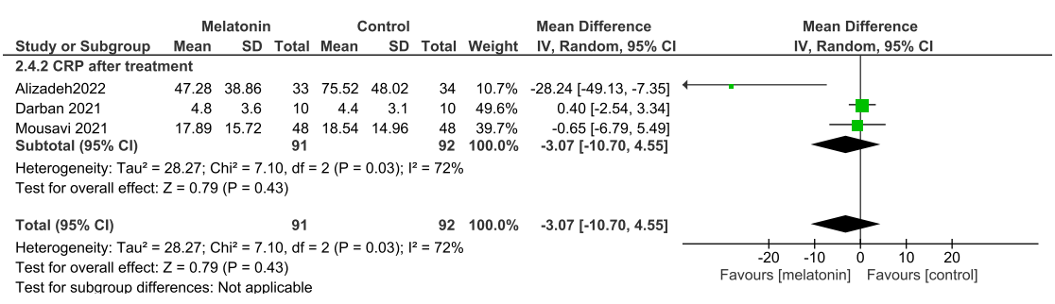
Supplementary Fig. 5. Three articles reported data about C-reactive protein levels (CRP) after treatment. All articles reported the data in mg/L unit. There was no significant difference.

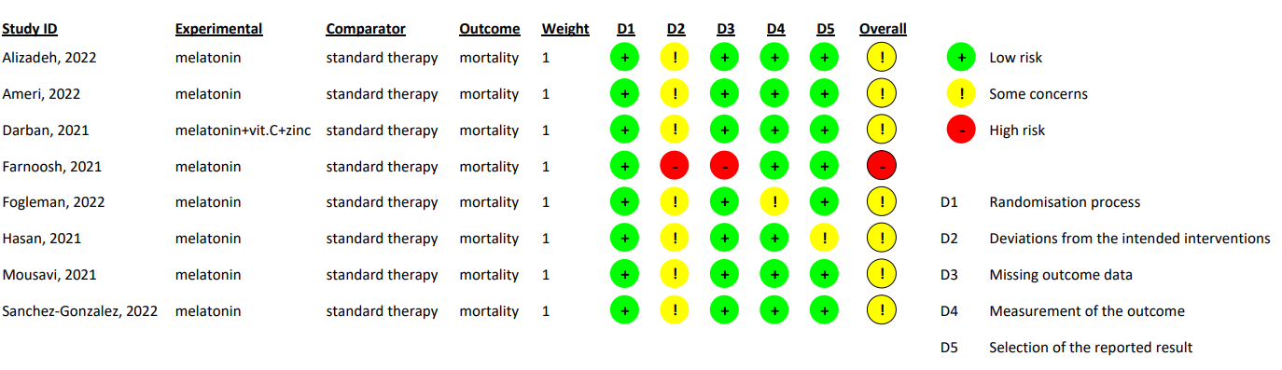
Supplementary Fig. 6. Randomized studies risk of bias. To assess the risk of bias RoB 2 [3] method was used. All the articles have at least some concerns in the D2 section (deviation from the intended intervention), while in one case we found high risk of bias in this section. Farnoosh et al. also reported high risk of bias in D3 section (missing outcome data), contributing to assess high overall risk of bias for this study. In one case in D5 section (selection of reported data) also appeared some concerns. In conclusion all the other articles considered some concerns of risk of bias.

Supplementary References
[1] Zhou Y, Hou Y, Shen J, Mehra R, Kallianpur A, Culver DA, et al. A network medicine approach to investigation and population-based validation of disease manifestations and drug repurposing for COVID-19. PLOS Biology. 2020; 18: e3000970.
[2] Alizadeh Z, Keyhanian N, Ghaderkhani S, Dashti-Khavidaki S, Shokouhi Shoormasti R, Pourpak Z. A pilot study on controlling coronavirus disease 2019 (COVID-19) inflammation using melatonin supplement. Iranian Journal of Allergy, Asthma and Immunology. 2021; 20: 494–499.
[3] Sterne JAC, Savović J, Page MJ, Elbers RG, Blencowe NS, Boutron I, et al. RoB 2: a revised tool for assessing risk of bias in randomised trials. BMJ. 2019; 366: l4898.
[4] Ziaei A, Davoodian P, Dadvand H, Safa O, Hassanipour S, Omidi M, et al. Evaluation of the efficacy and safety of melatonin in moderately ill patients with COVID-19: a structured summary of a study protocol for a randomized controlled trial. Trials. 2020; 21: 882.
[5] García IG, Rodriguez-Rubio M, Mariblanca AR, de Soto LM, García LD, Villatoro JM, et al. A randomized multicenter clinical trial to evaluate the efficacy of melatonin in the prophylaxis of SARS-CoV-2 infection in high-risk contacts (MeCOVID Trial): a structured summary of a study protocol for a randomised controlled trial. Trials. 2020; 21: 466.
[6] Rodríguez-Rubio M, Figueira JC, Acuña-Castroviejo D, Borobia AM, Escames G, de la Oliva P. A phase II, single-center, double-blind, randomized placebo-controlled trial to explore the efficacy and safety of intravenous melatonin in patients with COVID-19 admitted to the intensive care unit (MelCOVID study): a structured summary of a study protocol for a randomized controlled trial. Trials. 2020; 21: 699.

